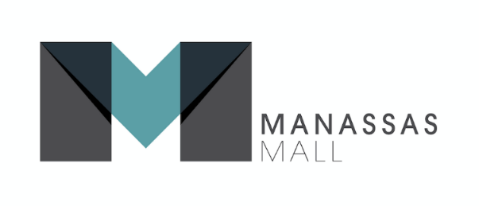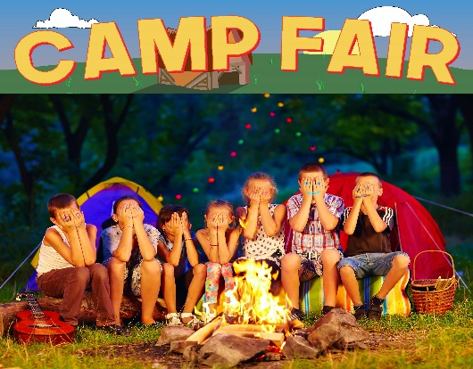
FOR IMMEDIATE RELEASE

Contact: Kelly Gilfether
Marketing Director/Manassas Mall
Telephone: 703-368-7232
Email: kellygilfether@pyramidmg.com

One Stop Shopping for Summer Camps at Manassas Mall!
Tweet this release: @ManassasMall Summer Camp Fair 2017 http://manassasmall.com/campfair
Manassas, VA. – Mark your calendars for the Manassas Mall Summer Camp Fair! It’s the perfect time for parents to plan for their kid’s summer camps and activities.
The Manassas Mall Summer Camp Fair is a one stop shop for summer camps and summer fun, where parents and kids can meet representatives from local camps and activity centers. The fair also features FREE entertainment, face painting, balloon twisting, prize drawings, plus a lot more. It’s Family fun for everyone at Manassas Mall!
The camp fair will be held March 4, 2017 from 11am-5pm in the At Home court near Walmart. *Camp Fair produced by KOJAM Productions Inc.
# # #

About Manassas Mall:
At Manassas Mall you can choose from over 80 top retail shops, with exciting entertainment options for families and adults! Autobahn Indoor Speedway features go-kart racing at speeds of up to 50mph. At Uptown Alley you can strike up the fun with live entertainment, 3 bar areas, bowling, a new laser tag arena, and more. Add that to our other full service sit down restaurants and a new food court. Make your shopping experience a truly exceptional one, where you can Eat, Shop, & Play all in one place. Kids play area Billy Beez now open. For further information on mall updates and events, please visit the website at www.ManassasMall.com. Like us on Facebook.com/ManassasMall and follow us on Twitter.com/ManassasMall and Instagram.com/ManassasMall.

