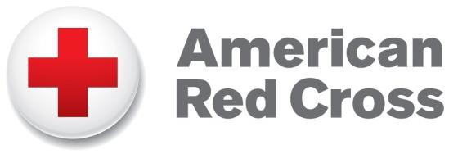
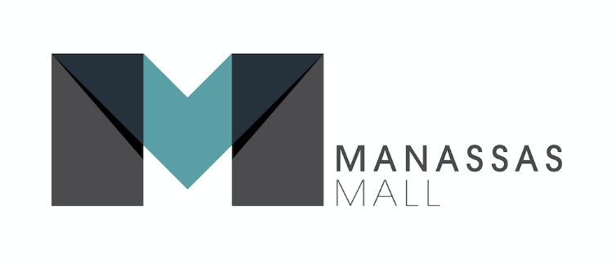

FOR IMMEDIATE RELEASE

Contact: Kelly Gilfether
Marketing Director/Manassas Mall
Telephone: 703.368.7232
E-mail: kellygilfether@pyramidmg.com

Manassas Mall to Host Blood Drive

Manassas, VA. – The American Red Cross is holding a Blood Drive at Manassas Mall on Friday, March 10, 2017. The drive will be located in the Community Room, located next to Sears from 1pm to 6pm and appointments are appreciated, however walk-ins are most definitely welcome.

One donation can help save up to three lives, please call (800) Red-Cross or go to www.redcrossblood.org and use code 20109 in the search box to schedule your life-saving donation.

###

About Manassas Mall
At Manassas Mall you can choose from over 80 top retail shops, with exciting entertainment options for families and adults! Autobahn Indoor Speedway features go-kart racing at speeds of up to 50mph. At Uptown Alley you can strike up the fun with live entertainment, 3 bar areas, bowling, a new laser tag arena, and more. Add that to our other full service sit down restaurants and a new food court. Make your shopping experience a truly exceptional one, where you can Eat, Shop, & Play all in one place. Kids play area Billy Beez now open. For further information on mall updates and events, please visit the website at www.ManassasMall.com. Like us on Facebook.com/ManassasMall and follow us on Twitter.com/ManassasMall and Instagram.com/ManassasMall.

