

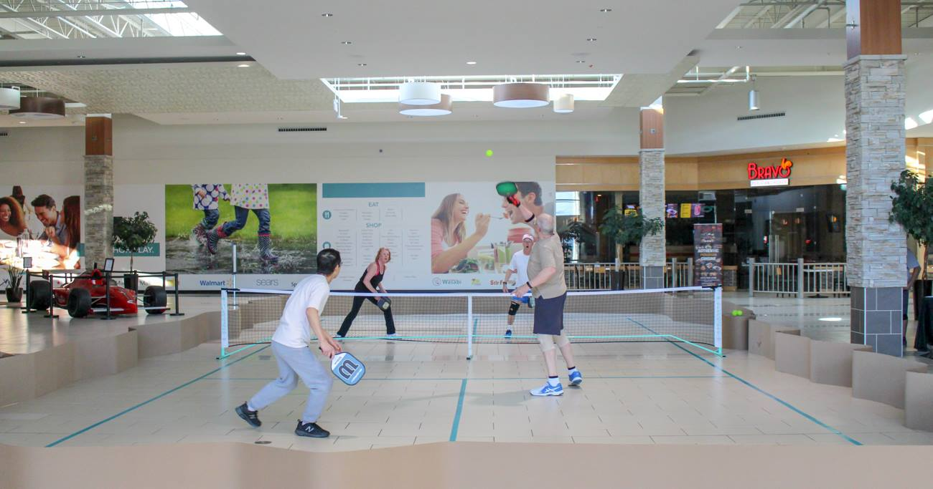

**FOR IMMEDIATE RELEASE**

March 20, 2019

Contact: Kelly Gilfether

Marketing Director/Manassas Mall

Telephone: 703.368.7232

E-mail: [kellygilfether@pyramidmg.com](mailto:kellygilfether@pyramidmg.com)

**“Pickleball with the Dominion Dinkers”**

**Manassas, VA –** Manassas Mall and the Dominion Dinkers are showing area residents what Pickleball is all about! Staying fit and active doesn’t mean you can’t have fun and meet new friends too. Pickleball has become a wildly popular sport for adults and kids of all ages, in fact there are an estimated 2.5 million players in the US with over 15,000 indoor and outdoor courts.

This fun paddle sport is for all ages and skill levels. The game combines elements of tennis, badminton and ping-pong, and is played with a paddle and whiffle ball in singles or in teams of two. The rules are simple and the game is easy for beginners to learn. But don’t be fooled, this sport can develop into a quick, fast-paced, competitive game for experienced players!

Join the Dominion Dinkers at Manassas Mall on Thursday, March 21st from 11am-2pm and Friday, March 22nd 2pm -5pm in the court area near Uptown Alley. The Dominion Dinkers will demonstrate the basics of the game and let spectators take a paddle and hit a few balls. Everyone is welcomed, come by and give it a try!

For further information on mall updates and events, please visit the Manassas Mall website at [www.ManassasMall.com](http://www.manassasmall.com/). Like the mall on [Facebook.com/ManassasMall](http://www.facebook.com/manassasmall) and follow on [Twitter.com/ManassasMall](http://www.twitter.com/manassasmall) and [Instagram.com/ManassasMall](https://instagram.com/manassasmall/).

###

**About Manassas Mall:** Manassas Mall is a dining, shopping and entertainment destination located on Sudley Rd. near I-66 in Western Prince William County.  Anchored by At Home, Macy’s, Sears and Walmart, the center offers more than 75 top retail shops, sit down dining and family entertainment options. With a truly unique and diverse tenant mix, Manassas Mall is the place to Eat, Shop, and Play.

**About Pyramid Management Group, LLC:** Pyramid Management Group, owner of Manassas Mall, is one of the largest, most innovative, privately-held shopping center developers in the northeast. Headquartered in Syracuse, New York, Pyramid’s portfolio of retail-based, tourist and entertainment destinations dominate the northeast with 18 properties located throughout New York, Massachusetts and Virginia. For over 40 years, Pyramid has led the industry in combining the best elements of traditional retail with world-class dining, entertainment and hospitality, all under one roof. For more information, visit [www.pyramidmg.com](http://www.pyramidmg.com).