 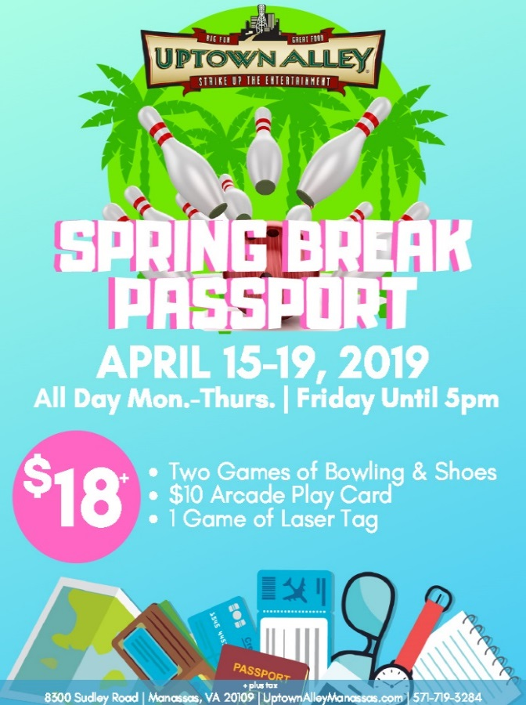

**FOR IMMEDIATE RELEASE**

April 8, 2019

Contact: Kelly Gilfether

Marketing Director/Manassas Mall

Telephone: 703.368.7232

E-mail: [kellygilfether@pyramidmg.com](mailto:kellygilfether@pyramidmg.com)

**SPRING BREAK BOREDOM BUSTERS**

**Manassas, VA –** Are you wondering how you’re going to keep the kids occupied and not go crazy during spring break. Grab the kids and join Manassas Mall with Spring Break Boredom Busters!

**Spring Break Passport** April 15th-19th at Uptown Alley; get two games of bowling & shoes, one game of laser tag, plus a $10 arcade card for $18.

**Arrive & Drive** **at Autobahn Indoor Speedway** with the ultimate racing experience! Jr. kart racing for kids 8-12, and 48” tall can experience the thrill of performance go-karting in a safe, controlled environment with speeds of up to 25mph. Adults and teens 13 and older, and 56” tall can drive at speeds up to 50 mph in Italian made, 3rd generation electric karts. After the race, all racers receive a detailed print out of their lap times, position, and ranking information. See who walks away with bragging rights!

**Billy Beez** is the ultimate indoor play park in Prince William County! Kids run, jump, bounce, slide, and climb their way into adventure with all day play passes!

With over 75 top retail shops, along with sit down dining and family entertainment options Manassas Mall is the place to Eat, Shop and Play.

For further information on mall updates and events, please visit the Manassas Mall website at [www.ManassasMall.com](http://www.ManassasMall.com). Like the mall on [Facebook.com/ManassasMall](http://www.facebook.com/manassasmall) and follow on [Twitter.com/ManassasMall](http://www.twitter.com/manassasmall) and [Instagram.com/ManassasMall](https://instagram.com/manassasmall/).

###

**About Manassas Mall:** Manassas Mall is a dining, shopping and entertainment destination located on Sudley Rd. near I-66 in Western Prince William County. Anchored by At Home, Macy’s, Sears and Walmart, the center offers more than 75 top retail shops, sit down dining and family entertainment options. With a truly unique and diverse tenant mix, Manassas Mall is the place to Eat, Shop, and Play.

**About Pyramid Management Group, LLC:** Pyramid Management Group, owner of Manassas Mall, is one of the largest, most innovative, privately-held shopping center developers in the northeast. Headquartered in Syracuse, New York, Pyramid’s portfolio of retail-based, tourist and entertainment destinations dominate the northeast with 18 properties located throughout New York, Massachusetts and Virginia. For over 40 years, Pyramid has led the industry in combining the best elements of traditional retail with world-class dining, entertainment and hospitality, all under one roof. For more information, visit www.pyramidmg.com.