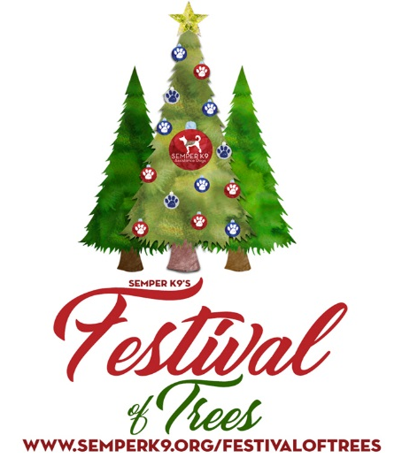
FOR IMMEDIATE RELEASE
September 17, 2019
Contact: Kelly Gilfether
Marketing Director/Manassas Mall
Telephone: 703.368.7232
E-mail: kellygilfether@pyramidmg.com

Designers & Sponsors Needed For Semper K9 Festival of Trees Fundraiser
Manassas, VA. – Semper K9 and Manassas Mall are looking for community groups, organizations or businesses to sponsor Christmas trees for the first annual Semper K9 Festival of Trees. The event will be held November 8th-17th at Manassas Mall and will feature a holiday themed room filled with Christmas trees that are uniquely designed and decorated by sponsors.
Combat veteran founded and operated, Semper K9’s mission is to enhance the quality of life for wounded and disabled service members by providing them with trained service dogs. Using rescued and donated dogs, Semper K9 trains and places service dogs free of charge with wounded service members.
Trees donated to the Festival of Trees will be displayed for shoppers and visitors in the mall, and various events will take place to showcase them. On November 17th all trees will be auctioned off at a special VIP auction, and proceeds from the auction will benefit the Semper K9 Assistance Dogs program.
For more information about the Festival of Trees, Semper K9 organization or to sponsor a tree, please contact Amanda Baity at amanda@semperk9.org.
###
About Semper K9 Assistance Dogs: Semper K9 Assistance Dogs is a combat veteran founded and operated 501(c)(3) nonprofit that provides assistance dogs for wounded, critically ill and injured members of the U.S. Armed Forces and their families. Christopher Baity, Semper K9’s Executive Director, is an OEF/OIF combat veteran Marine Corps dog trainer and kennel master with three combat deployments, one civilian deployment and two additional overseas deployments with military working dogs. Learn more about Semper K9 at www.SemperK9.org and follow them on social media: @SemperK9

About Manassas Mall: Manassas Mall is a dining, shopping and entertainment destination located on Sudley Rd. near I-66 in Western Prince William County. Anchored by At Home, Macy’s, Sears and Walmart, the center offers more than 75 top retail shops, sit down dining and family entertainment options. With a truly unique and diverse tenant mix, Manassas Mall is the place to Eat, Shop, and Play. For further information on mall updates and events, please visit the website at www.ManassasMall.com. Like us on Facebook.com/ManassasMall and follow us on Twitter.com/ManassasMall and Instagram.com/ManassasMall.
About Pyramid Management Group, LLC: Pyramid Management Group, owner of Manassas Mall, is one of the largest, most innovative, privately-held shopping center developers in the northeast. Headquartered in Syracuse, New York, Pyramid’s portfolio of retail-based, tourist and entertainment destinations dominate the northeast with 18 properties located throughout New York, Massachusetts and Virginia. For over 40 years, Pyramid has led the industry in combining the best elements of traditional retail with world-class dining, entertainment and hospitality, all under one roof. For more information, visit www.pyramidmg.com.

